PRESS RELEASE

Antwerp Airport announces satisfactory year results 2017

Antwerp, 5th January 2018 – During the year 2017 Antwerp Airport welcomed 273.167 passengers and registered 37.511 flight movements.
Results
In 2017 the airport welcomed 273.167 passengers, a slight decrease of 1% compared to 2016 when the airport registered 276.523 passengers. Several elements had an impact on the results. In 2016 20.000 additional passengers were unable to fly from Brussels Zaventem following the Terrorist Attacks and flew in March and April from Antwerp Airport.
When excluding these passengers from the total result, Antwerp Airport would achieve in 2017 an increase of 6% compared to 2016. Uncertainties at CityJet and VLM also caused less passengers on flights to London City.
The number of flight movements decreased by 9% with a total of 37.511 movements in 2017 compared to 41.403 movements during 2016.
Future
At the end of 2017, TUI launched flights to Innsbruck. A very popular destination for those who enjoy a short ski break or simply the Austrian snow. VLM will launch on January 22nd, two daily flights Antwerp-Zürich. Later this year the airport welcomes Flybe with flights to London Southend and the newest TUI route to Florence.
Marcel Buelens, CEO of Ostend-Bruges and Antwerp Airport said: “Passengers clearly prefer the advantages of flying from their regional airports in Flanders. In 2018 we will continue our recent developments and embrace new challenges. We will also focuss on accessibility and brand awareness abroad in order to attrackt further incoming passengers.”

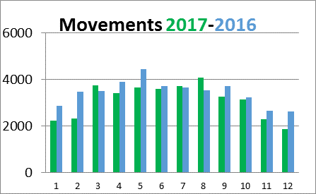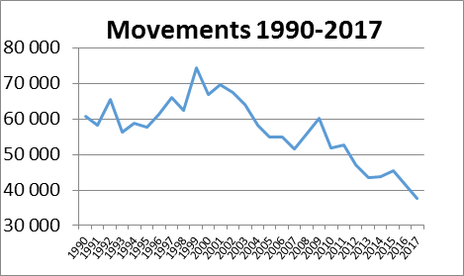

Stats
 | 2016 | 2017 | Difference %
passengers | 276 523 | 273 167 | -1%
Passengers * | 256 640 | 273 167 | +6%
Movements | 41 403 | 37 511 | -9%
Passengers *: this amount reflects the number of passengers excluding the additional passengers following the terrorist attacks of March 2016.
Best month September 27.758 passengers
Most popular destination London City
Total number of staff 74
Number of airlines 3
Number of routes 16

About Antwerp Flanders International Airport
Antwerp International Airport is part of the Egis Group. 16 European routes are currently operated by 3 airlines. Besides scheduled flights, the airport caters for private- charter- and training flights. The regional airport is well known for its speedy check-in, short walking distances and affordable parking.
During the year 2017 Antwerp Airport welcomed 273.167 passengers and registered 37.511 flight movements.
www.antwerpairport.aero

Press contact – Antwerp Flanders International Airport
Catherine Stuyck – catherine.stuyck@antwerpairport.aero

